Google App Engine Development Environment Setup

This document describes how to get your environment setup for Google App Engine Development using the Java programming language.

# Assumptions

1. You are familiar with Java programming language, Java Web Development specifically JSP/Servlets and have used Eclipse at the basic level
2. The Java SDK has been installed on your system. If you already have it setup, skip to next step. If not, you will have to install either Java 6 or Java 7. Please download the SDK and install that. Do not use the JRE version since we have to compile the JSPs. Make sure that JDK is available on the System PATH also.

# Eclipse Setup

To make things easier, we have packaged Eclipse, App Engine SDK 1.7.7.1 and the Google Eclipse plugin into a single RAR file for you to make things easier.

Follow these steps:

1. Expand the **gdg-ahmedabad-appengine-2013.rar** into C:\ or D:\ root folder. For the purpose of this documentation, the RAR file has been unzipped in the C:\ folder.
2. These will create a **c:\ gdg-ahmedabad-appengine-2013** folder on your machine in which you will find the following directories:

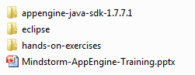

1. The executable for Eclipse is present in eclipse folder. The file name is eclipse.exe. You may want to keep a shortcut on your desktop for easy reference.
2. Launch eclipse\eclipse.exe file. This will be your primary development environment.
3. If it asks you for a workspace, give it the following directory as shown below:

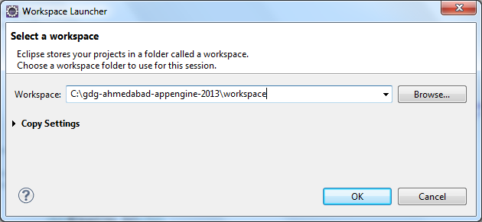

This will keep all your projects in the workspace directory and it will be easy for you to refer to it later on.

1. Check in the Eclipse main toolbar. You should see an icon for the Google Eclipse Plug-in:  
   
2. If you click the above, you will see various options as shown below:

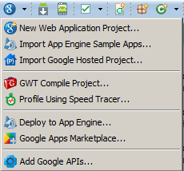

1. From the Eclipse Main menu, click on **Window 🡪 Preferences.** Go to **Google 🡪App Engine.** You will see an empty list for SDKs as shown below:

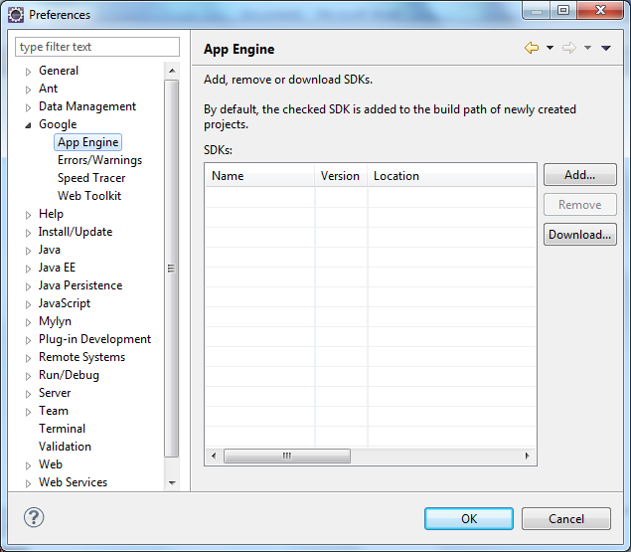

1. Click on the **Add** button, this will bring up the dialog shown below where you can assign a particular SDK version that you want to use:

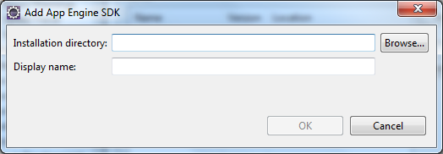

1. Click on **Browse** and navigate to **C:\gdg-ahmedabad-appengine-2013\appengine-java-sdk-1.7.7.1** as shown below:  
   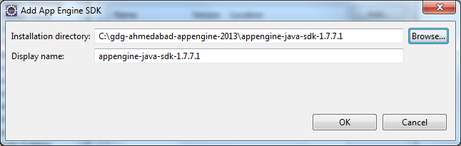
2. Click on **OK**. This will select the App Engine SDK 1.7.7.1 as shown below:  
   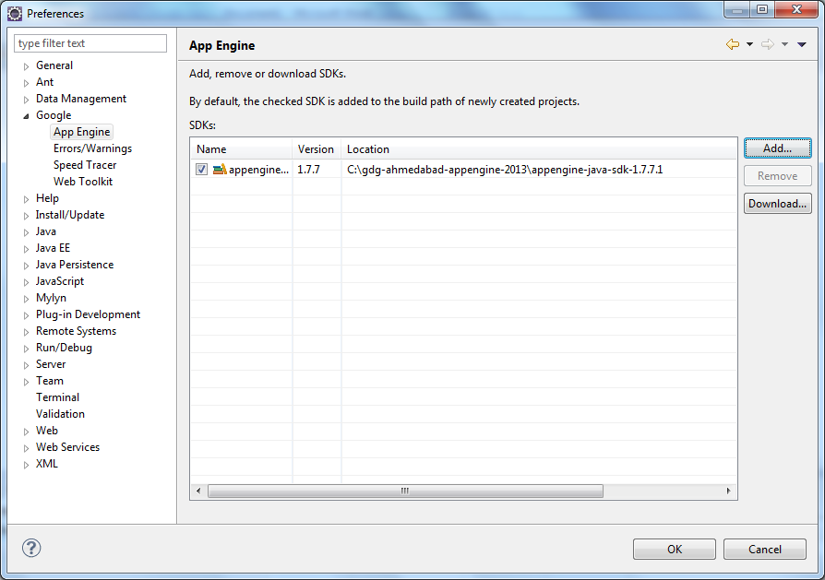
3. Click on **OK.**

**Congratulations**! Your Environment is all set to do App Engine Development with Java.